1. Using Insert Function, give examples of any function available in the

different dropdowns present in the function library. For example

AutoSum, Recently Used, Text, Date & Time, etc.

The parts of a function

In order to work correctly, a function must be written a specific way, which is called the **syntax**. The basic syntax for a function is the **equals sign (=)**, the **function name**(SUM, for example), and one or more **arguments**. Arguments contain the information you want to calculate. The function in the example below would add the values of the cell range A1:A20.

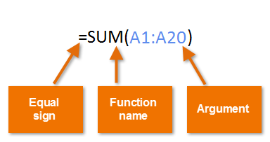

Working with arguments

Arguments can refer to both **individual cells** and **cell ranges**and must be enclosed within **parentheses**. You can include one argument or multiple arguments, depending on the syntax required for the function.

For example, the function **=AVERAGE(B1:B9)**would calculate the **average** of the values in the cell range B1:B9. This function contains only one argument.

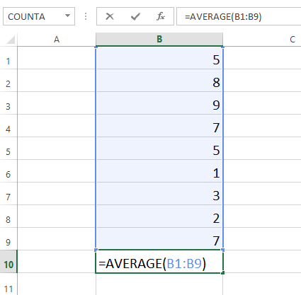

Multiple arguments must be separated by a **comma**. For example, the function **=SUM(A1:A3, C1:C2, E1)**will **add** the values of all the cells in the three arguments.

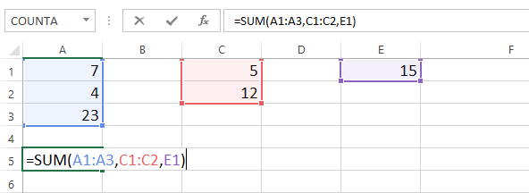

Creating a function

Excel has a variety of functions available. Here are some of the most common functions you'll use:

* **SUM**: This function **adds** all of the values of the cells in the argument.
* **AVERAGE**: This function determines the **average** of the values included in the argument. It calculates the sum of the cells and then divides that value by the number of cells in the argument.
* **COUNT**: This function **counts** the number of cells with numerical data in the argument. This function is useful for quickly counting items in a cell range.
* **MAX**: This function determines the **highest** **cell value** included in the argument.
* **MIN**: This function determines the**lowest cell value** included in the argument.

To create a basic function:

In our example below, we'll create a basic function to calculate the **average price** **per unit**for a list of recently ordered items using the AVERAGE function.

1. Select the **cell** that will contain the function. In our example, we'll select cell **C11**.

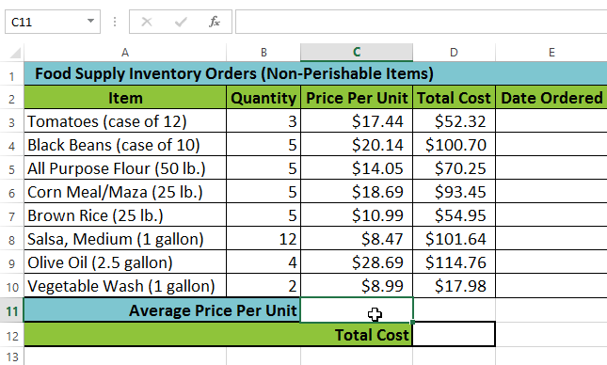

1. Type the **equals sign (=)** and enter the desired **function name**. You can also select the desired function from the list of **suggested** **functions** that will appear below the cell as you type. In our example, we'll type **=AVERAGE**.

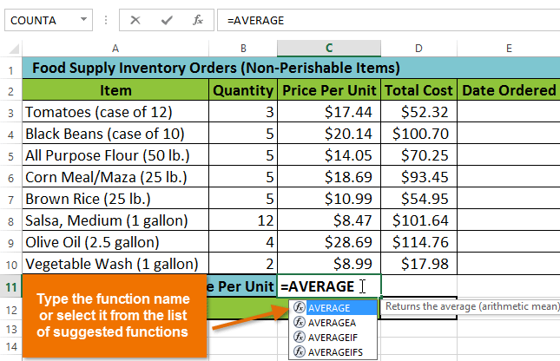

1. Enter the **cell range** for the **argument**inside **parentheses**. In our example, we'll type **(C3:C10)**. This formula will add the values of cells C3:C10 and then divide that value by the total number of cells in the range to determine the average.

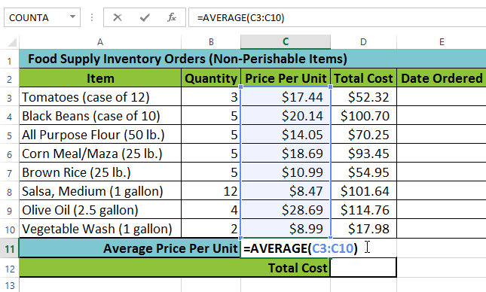

1. Press **Enter** on your keyboard. The function will be **calculated**, and the **result** will appear in the cell. In our example, the average price per unit of items ordered was **$15.93**.

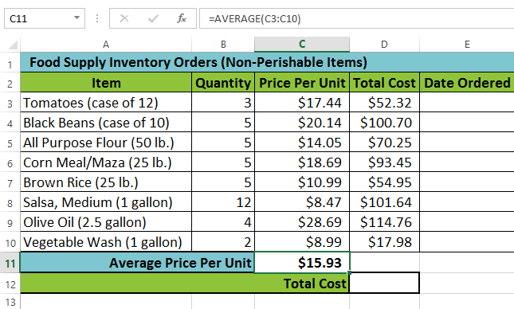

Excel **will not always tell you** if your formula contains an error, so it's up to you to check all of your formulas. To learn how to do this, read the [**Double-Check Your Formulas**](http://www.gcflearnfree.org/excelformulas/doublecheck-your-formulas/1/) lesson from our [**Excel Formulas**](http://www.gcflearnfree.org/excelformulas) tutorial.

To create a function using the AutoSum command:

The **AutoSum**command allows you to automatically insert the most common functions into your formula, including SUM, AVERAGE, COUNT, MIN, and MAX. In our example below, we'll create a function to calculate the **total cost** for a list of recently ordered items using the SUM function.

1. Select the **cell** that will contain the function. In our example, we'll select cell **D12**.

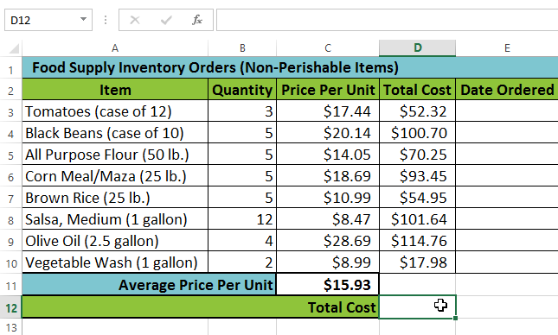

1. In the **Editing**group on the **Home** tab, locate and select the **arrow** next to the **AutoSum**command and then choose the **desired function** from the drop-down menu. In our example, we'll select **Sum**.

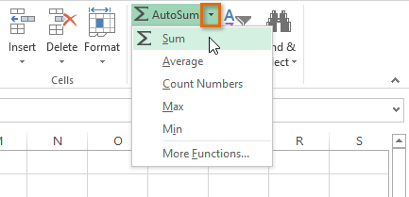

1. The selected **function**will appear in the cell. If logically placed, the AutoSum command will **automatically** select a cell range for the argument. In our example, cells **D3:D11** were selected automatically and their values will be **added** together to calculate the total cost. You can also manually enter the desired cell range into the argument.

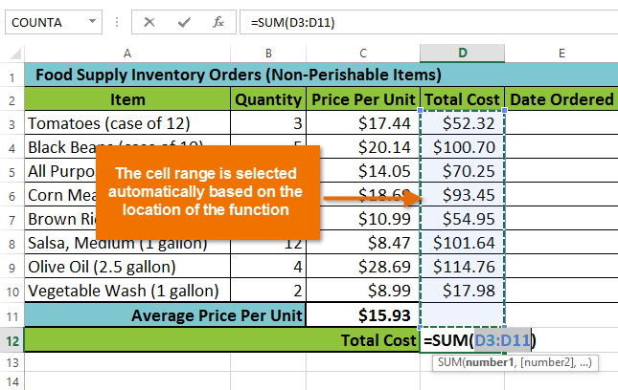

1. Press **Enter** on your keyboard. The function will be **calculated**, and the **result** will appear in the cell. In our example, the sum of D3:D11 is **$606.05**.

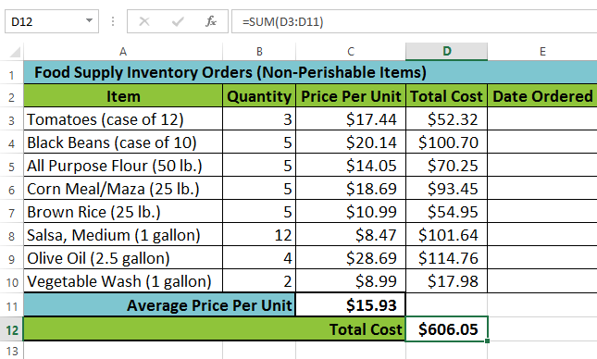

2. What are the different ways you can select columns and rows?

Select one or more rows and columns

Or **click on any cell in the column and then press Ctrl + Space**. Select the row number to select the entire row. Or click on any cell in the row and then press Shift + Space. To select non-adjacent rows or columns, hold Ctrl and select the row or column numbers.

3. What is AutoFit and why do we use it?

AutoFit is **a feature in Excel that lets you easily change the size of one or multiple columns or rows on a spreadsheet**. It helps you make sure that all the data in every cell group is clearly visible

1. How can you insert new rows and columns into the existing table?
2. Add a row or column
3. You can add a row above or below the cursor position.
4. Click where you want in your table to add a row or column and then click the **Layout** tab (this is the tab next to the **Table Design**tab on the ribbon).
5. To add rows, click **Insert Above** or **Insert Below** and to add columns, click **Insert Left** or **Insert Right**.
6. 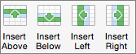
7. **Tip:**To add a row at the end of a table, click the last cell of the last row, and then press the TAB key.
8. Delete a row, cell, or table
9. Click a row or cell in the table, and then click the **Layout** tab (this is the tab next to the **Table Design**tab on the ribbon).
10. Click **Delete**, and then click the option your need in the menu.
11. **Note:**The option to delete the table on the **Delete** menu is only in Word. If you want to delete a table in PowerPoint, select and delete it.
12. 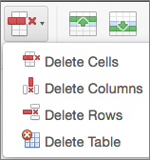
13. How do you hide and unhide columns in excel?

Hide or show rows or columns

*Excel for Microsoft 365 Excel for Microsoft 365 for Mac Excel for the web*[*More...*](javascript:)

Hide or unhide columns in your spreadsheet to show just the data that you need to see or print.

Hide columns

1. Select one or more columns, and then press Ctrl to select additional columns that aren't adjacent.
2. Right-click the selected columns, and then select **Hide**.

**Note:**The double line between two columns is an indicator that you've hidden a column.

Unhide columns

1. Select the adjacent columns for the hidden columns.
2. Right-click the selected columns, and then select **Unhide**.

    Or double-click the double line between the two columns where hidden columns exist.

6. Create an appropriate table within the worksheet and use different

functions available in the AutoSum command.

If you need to sum a column or row of numbers, let Excel do the math for you. Select a cell next to the numbers you want to sum, click **AutoSum** on the **Home** tab, press **Enter**, and you’re done.

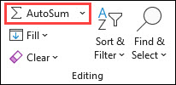

When you click **AutoSum**, Excel automatically enters a formula (that uses the [SUM function](https://support.microsoft.com/en-us/office/sum-function-043e1c7d-7726-4e80-8f32-07b23e057f89)) to sum the numbers.

Here’s an example. To add the January numbers in this Entertainment budget, select cell B7, the cell immediately below the column of numbers. Then click **AutoSum**. A formula appears in cell B7, and Excel highlights the cells you’re totaling.

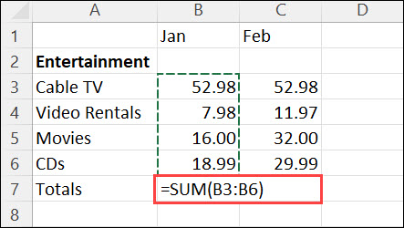

Press Enter to display the result (95.94) in cell B7. You can also see the formula in the formula bar at the top of the Excel window.

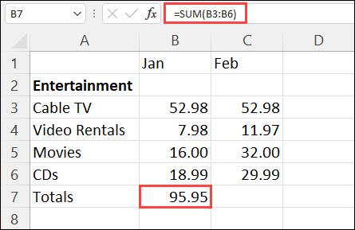

**Notes:**

* To sum a column of numbers, select the cell immediately below the last number in the column. To sum a row of numbers, select the cell immediately to the right.
* **AutoSum** is in two locations: **Home** > **AutoSum**, and **Formulas** > **AutoSum**.
* Once you create a formula, you can copy it to other cells instead of typing it over and over. For example, if you copy the formula in cell B7 to cell C7, the formula in C7 automatically adjusts to the new location, and calculates the numbers in C3:C6.
* You can also use AutoSum on more than one cell at a time. For example, you could highlight both cell B7 and C7, click **AutoSum**, and total both columns at the same time.
* You can also sum numbers by [creating a simple formula](https://support.microsoft.com/en-us/office/use-excel-as-your-calculator-a1abc057-ed11-443a-a635-68216555ad0a).